Follow the steps given below to create a group and a user in that group:

$ clear
$ sudo addgroup hadoopgroup1
$ sudo adduser –ingroup hadoopgroup hadoopuser1
To give permission to group
$sudo gedit /etc/sudoers - will open a file...in that...

Add the following line (after %sudo ALL=(ALL:ALL) ALL)
%hadoopgroup1 ALL=(ALL:ALL) ALL

Change the user form existing user… to hadoopuser
LOGOUT of the present user
LOGIN with the newly created user “hadoopuser”

After this, if you type pwd, we should get
$hadoopuser@ .......
________________________________________________________________
sudo apt update

sudo apt install openjdk-8-jdk -y

java -version; javac -version

sudo apt install openssh-server openssh-client -y

sudo apt-get install vsftpd

ssh-keygen -t rsa -P '' -f ~/.ssh/id_rsa

cat ~/.ssh/id_rsa.pub >> ~/.ssh/authorized_keys

chmod 0600 ~/.ssh/authorized_keys

ssh localhost

wget https://downloads.apache.org/hadoop/common/hadoop-3.3.4/hadoop-3.3.4.tar.gz

tar xzf hadoop-3.3.4.tar.gz

sudo nano .bashrc

#Hadoop Related Options
export HADOOP_HOME=/home/hduser/hadoop-3.3.4 export HADOOP_INSTALL=$HADOOP_HOME
export HADOOP_MAPRED_HOME=$HADOOP_HOME
export HADOOP_COMMON_HOME=$HADOOP_HOME
export HADOOP_HDFS_HOME=$HADOOP_HOME
export YARN_HOME=$HADOOP_HOME
export HADOOP_COMMON_LIB_NATIVE_DIR=$HADOOP_HOME/lib/native
export PATH=$PATH:$HADOOP_HOME/sbin:$HADOOP_HOME/bin
export HADOOP_OPTS="-Djava.library.path=$HADOOP_HOME/lib/native"

source ~/.bashrc

sudo nano $HADOOP_HOME/etc/hadoop/hadoop-env.sh

and paste
export JAVA_HOME=/usr/lib/jvm/java-8-openjdk-amd64

which javac

readlink -f /usr/bin/javac

sudo nano $HADOOP_HOME/etc/hadoop/core-site.xml

sudo nano $HADOOP_HOME/etc/hadoop/hdfs-site.xml

sudo nano $HADOOP_HOME/etc/hadoop/mapred-site.xml

sudo nano $HADOOP_HOME/etc/hadoop/yarn-site.xml

hdfs namenode -format

Navigate to the hadoop-3.3.4/sbin directory and paste
./start-dfs.sh
./start-yarn.sh
jps
Use your preferred browser and paste - http://localhost:9870
The default port 9864 is used to access individual DataNodes directly from your browser:
http://localhost:9864
The YARN Resource Manager is accessible on port 8088:
http://localhost:8088
_____________________________________________________________
Then dealing with file:
hdfs dfs -mkdir hdfs://localhost:9000/hinput
hdfs dfs -ls hdfs://localhost:9000/
hdfs dfs -put ./Downloads/example.txt hdfs://localhost:9000/hinput

Created another dir hinput2 and added covid_data file..(convert .xlsx to csv)
hdfs dfs -put /home/hduser/Downloads/covid_data.csv hdfs://localhost:9000/hinput2 (another way)
Go to browserand select Namenode ...in that under datanode tab
select utilities – Browse the file system...select that...
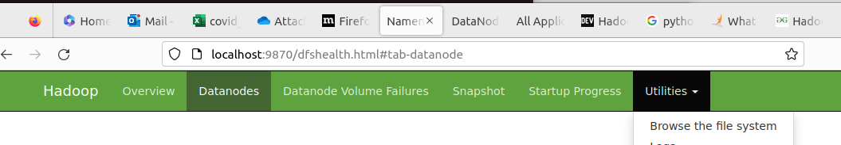
You can see th$ hadoop versione browse history with the created input dir..
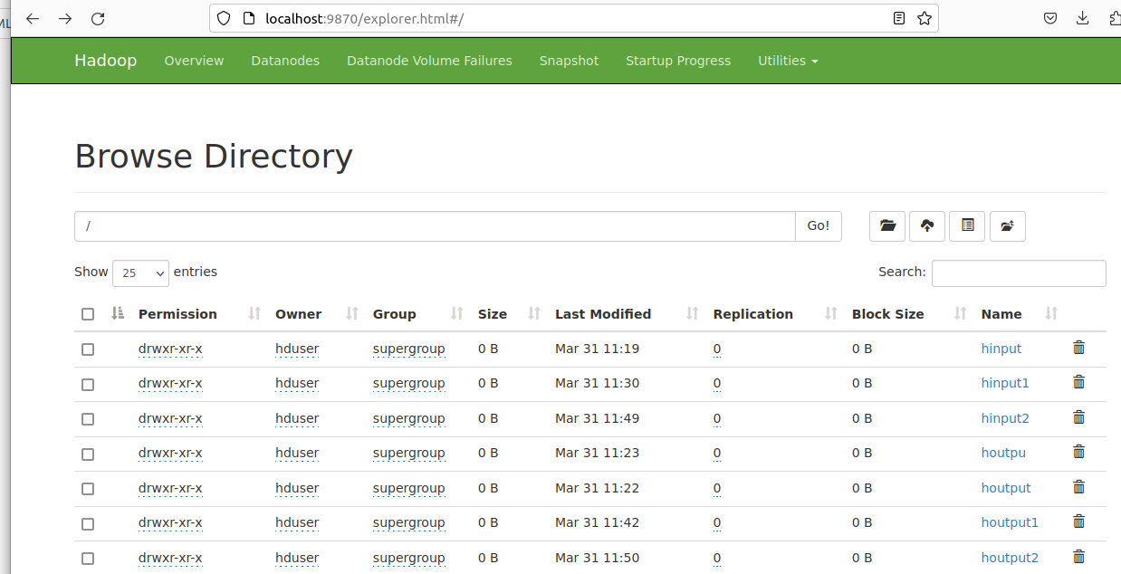
under hinput dir we have example.txt
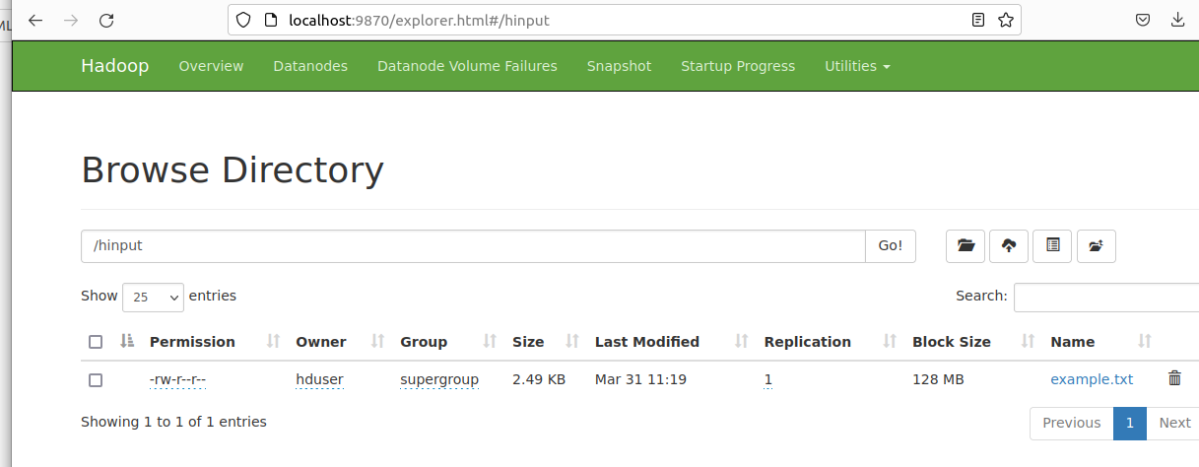
under hinput2 dir we have covid_data.xlsx
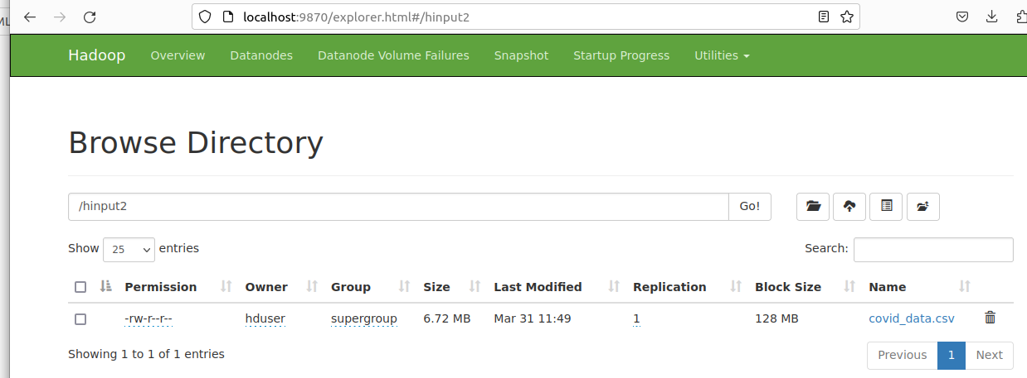
As we are executing standard wordcount file in java...we have to copy that file to current directory
cp ./hadoop-3.3.4/share/hadoop/mapreduce/hadoop-mapreduce-examples-3.3.4.jar . (after jar space dot represents current directory)
After this execute this command
hadoop jar hadoop-mapreduce-examples-3.3.4.jar wordcount hdfs://localhost:9000/hinput1 hdfs://localhost:9000/houtput1
So now... to see the outout:
hdfs dfs -cat hdfs://localhost:9000/houtput2/part-r-00000
note: we can also use the browser to see the input ditr , output dir and the result.

